**Name – Kamal D. Agrahari TE IT - A | Batch – B**

**ID – VU4F2223028 Subject – IP Lab**

Experiment No. 3 – A

**Aim** - Write a JavaScript program to calculate the volume of a cylinder. Volume of a cylinder:

V = πr2h. Define variables and π as constant.

**Program**:

<!DOCTYPE html>

<html lang="en">

<head>

<meta charset="UTF-8" />

<meta name="viewport" content="width=device-width, initial-scale=1.0" />

<title>Calculate Volume of Cylinder</title>

</head>

<body>

<h1>Volume of Cylinder</h1>

<p id="radius"></p>

<p id="height"></p>

<p id="volume"></p>

<script>

// Program to calculate Volume of a Cylinder

const pi = 3.141592653;

const radius = 5;

const height = 10;

const volumeOfCylinder = pi * radius * radius * height;

document.getElementById('radius').textContent = `Radius of Cylinder: ${radius}cm`;

document.getElementById('height').textContent = `Height of Cylinder: ${height}cm`;

document.getElementById('volume').textContent = `Calculated Volume of Cylinder: ${volumeOfCylinder} cubic cm`;

</script>

</body>

</html>

Output:

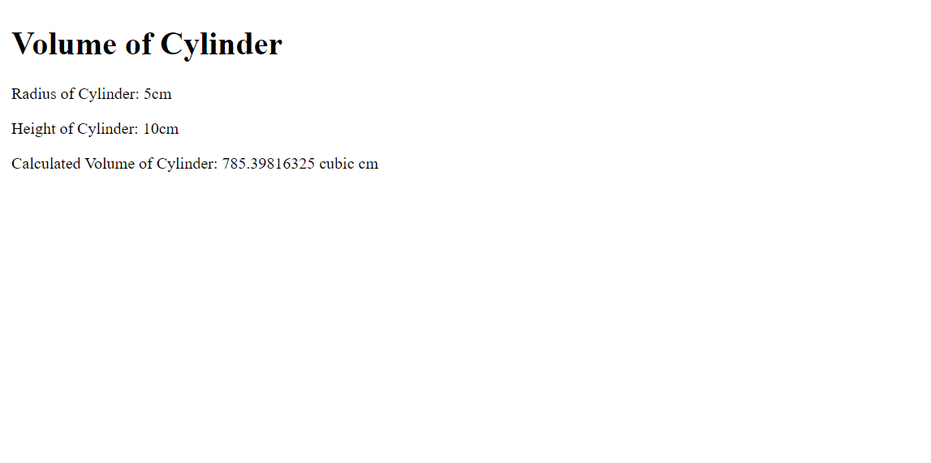

**Name –Kamal D. Agrahari TE IT - A | Batch – B**

**ID – VU4F2223028 Subject – IP Lab**

Experiment No. 3 – B

**Aim** - Write a JavaScript program to calculate simple interest. Accept principle amount, rate of interest and number of years from the user. Use function and arrow function to calculate interest.

Program

<!DOCTYPE html>

<html lang="en">

<head>

<meta charset="UTF-8" />

<meta name="viewport" content="width=device-width, initial-scale=1.0" />

<title>Interest Calculator</title>

<style>

input{

margin: 0px 0 20px 5px;

}

</style>

</head>

<body>

<h1>Calculate Your Simple Interest</h1>

<label for="principal">Enter your principal amount </label>

<input type="number" name="principal" id="principal" />

<br />

<label for="rate"

>Enter you interest rate (percentage value without % symbol)</label

>

<input type="number" name="rate" id="rate" />

<br />

<label for="year">Enter your number of years</label>

<input type="number" name="year" id="year" />

<button id="submit">Calculate Interest</button>

<p id="result"></p>

<script>

const principal = document.getElementById('principal')

const rate = document.getElementById('rate')

const year = document.getElementById('year')

const submit = document.getElementById('submit')

submit.addEventListener('click', () => {

document.getElementById('result').textContent = `Interest Amount = ${principal.value * (rate.value/100) * year.value}`;

})

</script>

</body>

</html>

Output

